Machine Learning 382 CYO Project:
Technical Report
Belgium campus itversity
Ofentse Vilakazi 603090
Nyameko Kraai 601558
Koketso Lebelo 601215
Mutshidzi Nduvheni 601781
Coenraad Vermaak 576023
Benno weideman 602904
2026
Table of Contents
1.Business understanding 3
1.1 Introduction: 3
1.2 Problem Statement: 3
1.3 Business Goals 3
1.4 Project Goals 3
2. Data understanding 4
2.1 Data Collection 4
2.2 Data Description 4
2.3 Data Exploration 5
2.4 Data Quality Assessment 6
2.5 Feature Relevance 6
2.6 Initial Insights 6
3. Data Preparation 7
3.1 Data Cleaning 7
3.2 Handling Missing Values 7
3.3 Encoding Categorical Variables 8
3.4 Feature Transformation 9
3.5 Feature Scaling 10
3.6 Feature Selection 10
3.8 Final Dataset 10
4. Modelling 11
4.1 Model Selection 11
4.2 Data Preparation for Modelling 11
4.3 K-Means Clustering 11
4.4 DBSCAN Clustering 13
4.5 Self-Organizing Map (SOM) 14
5. Evaluation 16
5.1 Evaluation Approach 16
5.2 K-Means Evaluation 16
5.3 DBSCAN Evaluation 16
5.4 SOM Evaluation 17
5.5 Model Comparison 17
5.6 Final Model Selection 17
6. Deployment 17
6.1 Deployment Steps for Render 18
6.2 Links 18
7. Possible Future Improvements 18

1.Business understanding

1.1 Introduction:
A local business, called Woolworths Food, wants to tailor their marketing strategies and offerings to customers to increase profit and customer preference. However, they are struggling to understand customers’ demographics, behaviour, and transactional data that determine whether they will accept or ignore their last campaigns regarding their previous campaigns that were held. Woolworths Food has asked us, BC Data Scientists, to create machine learning models along with a DASH web application which will be deployed in render to aid the business’s prediction on customers’ likelihood to be in a distinct group. Woolworths has provided us with the marketing_campaign.csv file to start understanding what all the data is about.

1.2 Problem Statement:
Due to the high level of competition within the food retail environment, it is extremely important for businesses (like Woolworths Food) to be capable of continuously adapting their marketing strategies in order to retain and attract a diverse set of customer types within their stores. As we explained in our introduction, the current challenge being faced is that customers by their nature are diverse in terms of purchasing behaviours, making it difficult to apply a universal marketing strategy.
This project aims to help address this problem, by segmenting customers into distinct groups based on their demographic, behavioural, and transactional data. The segmentation of customers can then be used by Woolworths Food, in order to support more targeted marketing campaigns and strategies, improve customer retention levels, and increase their overall business profitability.

1.3 Business Goals
From a business perspective, the primary objective of this project would be the development of a data-driven customer segmentation system for Woolworths Food, which enables them to:
- Identify distinct customer groupings that exhibit similar characteristics.
- Obtain a better understanding of purchasing patterns and the value each customer provides.
- Tailor marketing campaigns towards certain customer groups that are more likely to provide value
- Optimize resource allocation for marketing efforts.
In other words, this project will help Woolworths Food move from a generalized marketing approach to a more personalized and efficient strategy.

1.4 Project Goals
From a machine learning perspective, our goal is to apply unsupervised learning techniques to discover patterns within the customer dataset. We will be making use of clustering algorithms, such as:
- K-Means
- DBSCAN
- Self-Organizing Maps (SOM)
We aim to identify the optimal number of clusters, compare the performance and clustering quality of these models, and interpret the clusters in a meaningful way. The outcome should be clearly defined customer segments that can be easily interpreted and used in decision making.

2. Data understanding

2.1 Data Collection
The dataset used for this project, marketing_campaign.csv, was provided by Woolworths Food and contains information on customer demographics, purchasing behaviour, and responses to marketing campaigns.
The dataset consists of 2240 customer records, with each row representing a unique customer with multiple features (columns) describing their personal characteristics, spending habits, and engagement with previous campaigns.

2.2 Data Description
The dataset includes a mix of numerical, categorical, and date-based variables, which can be grouped into one of three categories. Demographic Features describe a customer’s background and socio-economic status, this includes things like their age, income, and marriage status, amongst others. Spending Behaviours refer to any information regarding a customer’s purchases within the Woolworth Food store. Other Features include anything outside the other two categories, including things like a customer’s interactions with the store (Complaints, Previous Campaign Interactions, etc.).
The various features (columns) in the original dataset are grouped accordingly in the below tables, including a description of the purpose of each feature:
Demographic Features
Year_Birth | Year of birth of the customer
Dt_Customer | Date of customer registration
Education | Education level (Basic, 2n Cycle, Graduation, Master, PhD)
Marital_Status | Marital status (Single, Married, Together, etc.)
Income | Annual income of the customer
Kidhome | Number of children in the household
Teenhome | Number of teenagers in the household

Spending Behaviours
MntWines, MntFruits, MntMeatProducts, MntFishProducts, MntSweetProducts, MntGoldProducts | Amount purchased for different product categories
Recency | Number of days since the last purchase
NumDealsPurchases | Number of purchases made using discounts
NumWebPurchases | Number of online purchases
NumCatalogPurchases | Number of catalogue purchases
NumStorePurchases | Number of in-store purchases
NumWebVisitsMonth | Monthly website visits

Other Features
AcceptedCmp1 – AcceptedCmp5 | Whether the customer accepted previous campaigns (Binary)
Response | Response to the most recent campaign
Complain | Whether the customer has complained
Z_CostContact, Z_Revenue | Constant values across all records (likely irrelevant)
ID | Unique customer identifier

2.3 Data Exploration
An initial exploration of the dataset was conducted to understand its structure and to identify potential issues. We made some key observations regarding the data within. For instance, the dataset contains a combination of continuous and categorical variables, which require different pre-processing techniques to prepare. Some features, such as Income, contain a wide range of values, which could lead to possible outliers. The various spending variables help indicate the purchasing preferences of customers across various product categories. Campaign-related variables are binary and could be useful for understanding customer responsiveness. The Recency column provides insight into customer engagement levels and their activity levels.

2.4 Data Quality Assessment
Our data quality assessment revealed several areas of concern that needed to be addressed during the Data Preparation phase. For instance, the original dataset contains missing values, specifically within the Income column. Missing values will impact clustering performance and require appropriate handling (e.g., imputation or removal). With regards to possible outliers, numerical features such as Income and possibly other spending variables seem to contain extreme values which can significantly influence clustering algorithms like K-Means. We also found that the Z_CostContact and Z_Revenue columns contain constant values across all customer entries, and therefore don’t contribute meaningful information. Similarly, the ID column only serves as an identifier and will not be useful for modelling. Some categorical features, such as Education or Marital_Status could benefit from grouping or standardization (e.g., “Together”, “Married”), but it is not strictly necessary.

2.5 Feature Relevance
Not all features contribute equally to customer segmentation. Based on our initial analysis, feature relevance can be ranked as follows:
Highly relevant features
Income
Recency
Spending variables (Amt* columns, etc.)
Purchase counts
Monthly website visits.
Moderately relevant features
Education
Marital_Status
Household composition
Low or irrelevant features
ID
Z_CostContact
Z_Revenue
Campaign responses

2.6 Initial Insights
Our initial analysis led to the identification of several early insights. For instance, it is clear that customers exhibit diverse spending patterns that span multiple product categories. In addition to this, there is variation in the engagement levels of customers, as indicated by the recency and monthly web visits features. Income likely plays a significant role in customer purchasing behaviour and segmentation. The above observations support our use of clustering techniques to identify the various customer segments.

3. Data Preparation

3.1 Data Cleaning
Our initial dataset required that several cleaning steps be performed in order to remove irrelevant and redundant information. The ID column was removed as it serves only as a unique identifier and does not contribute to clustering. The Z_CostContact and Z_Revenue columns were also dropped, since were observed to contain constant values across all records and therefore provide no meaningful information for analysis. By doing this, we help reduce noise and improve the quality of the dataset for modelling purposes.
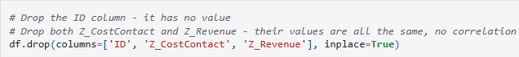

3.2 Handling Missing Values
An assessment of missing values revealed that the Income feature contained null entries.
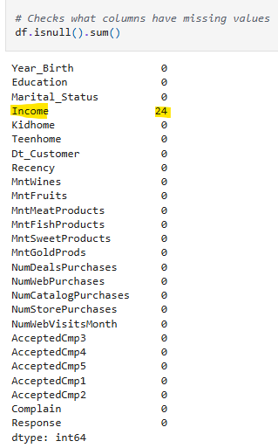
To address this, we chose to make use of a mean imputation strategy which we applied using the SimpleImputer. Missing values in the Income column were replaced with the mean income value of the dataset. This ensured that all records were retained while maintaining a reasonable estimate for missing values.

3.3 Encoding Categorical Variables
The dataset included multiple categorical variables such as Education and Marital_Status, which are not directly compatible with clustering algorithms and had to be adjusted. We proceeded by first converting all categorical values to lowercase to ensure consistency (Avoiding cases such where “Married =/= married”).
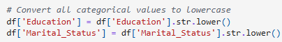
The categories were then mapped to numerical values. For instance, “Education” levels (e.g., graduation, phd, master) were encoded as integers. For marital status, the same was done, but with the addition of grouping certain categories together. For instance, “Together” and “Married” now fall under the category of “Partnered”.
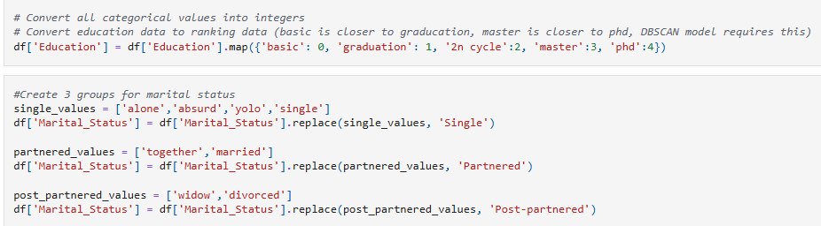
This allowed us to perform the following operation which creates three binary feature columns, for the new categories:
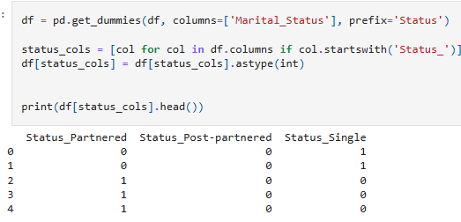

3.4 Feature Transformation
Date Conversion:
The Dt_Customer feature was converted from a date format into a Unix timestamp, which allows the model to interpret customer registration time as a numerical feature.
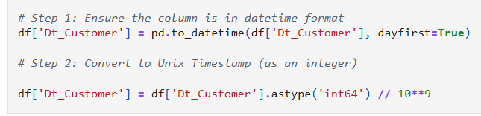
Outlier Detection and Treatment (Only for K-Means & SOM):
Outliers were identified using the Interquartile Range (IQR) method, which detects values outside the Lower (Q1 − 1.5 × IQR) or Upper (Q3 + 1.5 × IQR) bound ranges. This led to the following outlier counts:
Outliers
Feature | Count
Year_Birth | 3
Income | 8
MntWines | 35
MntFruits | 227
MntMeatProducts | 175
MntFishProducts | 223
MntSweetProducts | 248
MntGoldProds | 207
NumDealsPurchases | 86
NumWebPurchases | 4
NumCatalogPurchases | 23
NumWebVisitsMonth | 8

To handle these outliers, Winsorization was applied to most numerical features (excluding categorical and binary variables). This caps extreme values at the 5th and 95th percentiles, reducing the impact of extreme values without completely removing data points.
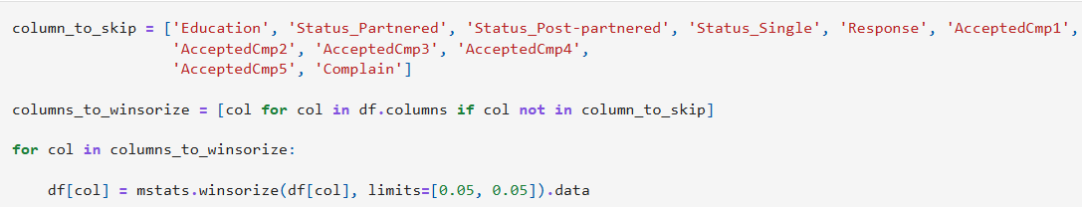

Log Transformation (Also only for K-Means and SOM)
To help further address skewness and reduce the impact of extreme values we also applied a log transformation (log1p) to all spending-related features (The columns starting with "Mnt"). This transformation helped us stabilize variance and improved the distribution of skewed data.
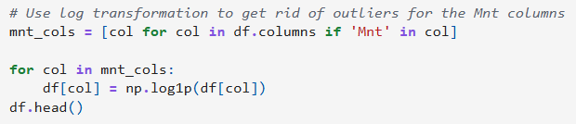

3.5 Feature Scaling
Clustering algorithms such as K-Means and SOM are sensitive to feature scales. Which meant that in order to ensure that all features contribute equally, we had to apply Standardization using the StandardScaler. The relevant features (Categorical and Binary values are excluded) were transformed to have a mean of 0 and standard deviation of 1.
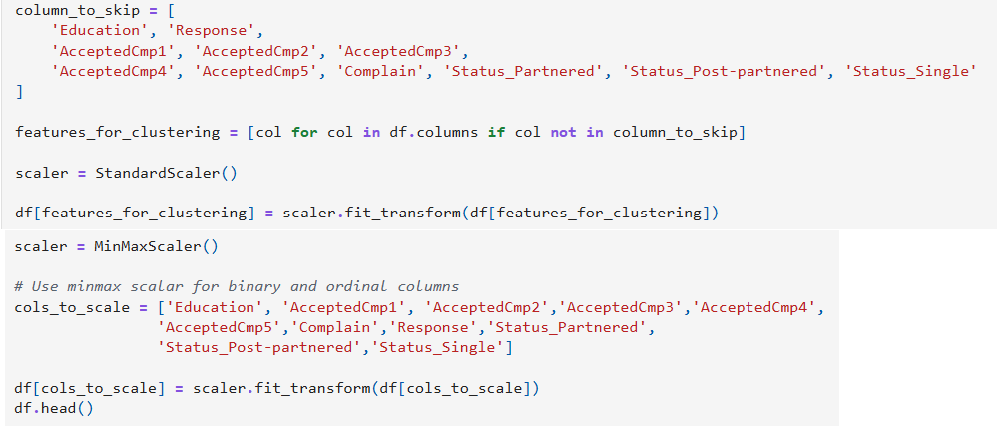

3.6 Feature Selection
Certain features were excluded from clustering to improve model performance. Identifier variables (ID), irrelevant features (e.g., Z_CostContact, Z_Revenue), and the Binary campaign response variables (AcceptedCmp1–5, Response, Complain) were excluded from clustering to improve model performance.

3.8 Final Dataset
After preprocessing, the new datasets contained cleaned and transformed features. They had reduced noise and outliers. They were now fully numerical and suitable for clustering algorithms, while also being standardized for optimal model performance.
The prepared datasets were saved as k_means_data.csv and SOM_data.csv, while the DBSCAN cleaned dataset was saved as DBSCAN_data.csv, for use in their respective subsequent modelling steps.

4. Modelling

4.1 Model Selection
To address our primary customer segmentation problem, unsupervised learning techniques were selected. Three clustering approaches were implemented and compared:
- K-Means Clustering (centroid-based)
- DBSCAN (density-based)
- Self-Organizing Map (SOM) (neural network-based)
These three models were chosen to provide a diverse range of perspectives on the data. K-Means was selected for structured, interpretable segmentation, while DBSCAN was chosen for density-based grouping and outlier detection, and finally SOM was picked for visualization and pattern discovery.

4.2 Data Preparation for Modelling
Before applying the models, we ensured that only numerical features were present. Missing values were handled using median imputation and the data was scaled using StandardScaler for K-Means and DBSCAN or MinMaxScaler for SOM. This ensured that all features contributed equally to distance-based calculations.

4.3 K-Means Clustering

4.3.1 Model Overview
K-Means clustering partitions data into k clusters by minimizing the variance within each cluster.

4.3.2 Optimal Cluster Selection
Two methods were used for optimal cluster selection, the first of which was the Elbow Method, where we select a range of K-Values, then for each k, we run K-Means and calculate the Within-Cluster Sum of Squares (WCSS). This value shows us how close the data points are to their cluster centroids. WCSS can be calculated using the below formula.
After calculating WCSS for all k values selected, we plot k vs WCSS. From the below graph, we can see that for our dataset, k=4 is the point where the rate of decrease in WCSS changes, indicating that adding more clusters beyond this point, will yield diminishing returns.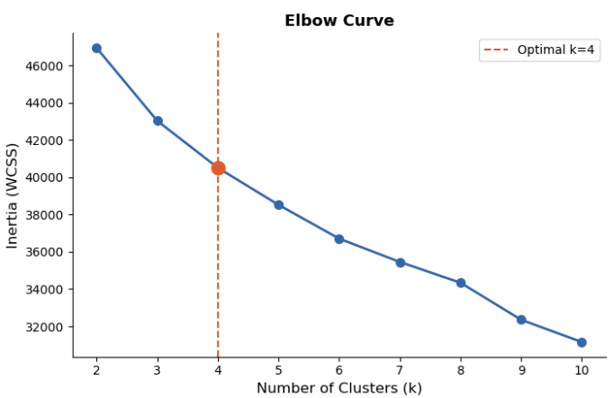
The second method was utilizing Silhouette Score, which resulted in the below graph for our dataset where k=2, had the highest score:
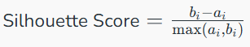
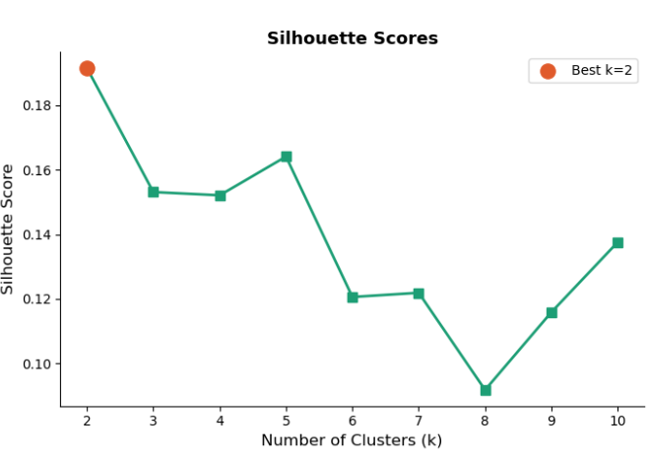
Even though the highest silhouette score was at k = 2 (0.1915), we still opted to select k = 4 based on the elbow curve and improved interpretability.

4.3.3 Results
After identifying k=4 as our optimal k-value, we ran the following code to obtain our cluster distribution:
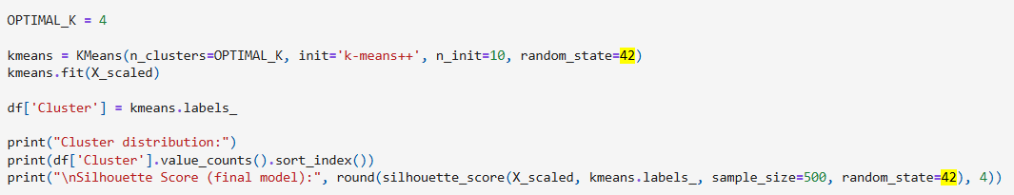
This resulted in the following Cluster distribution:
C0: | 602
C1: | 529
C2: | 888
C3: | 221
Silhouette Score (Final Model): | 0.1521

4.3.4 Cluster Interpretation
Four meaningful customer segments were identified using the K-Means model:
Cluster | Category: | Occurences: | Identifiers:
C0: | High-Value Buyers | 602 | High Income, High Spending
C1: | Budget Conscious | 529 | Low Income, Price Sensitive
C2: | Digital Shoppers | 888 | Strong Online Engagement
C3: | Passive Segment | 221 | Low Engagement and Spending

High-Value Buyers: This segment consists of high-income customers who spend heavily across all product categories, particularly wines and meat products. They shop across multiple channels and are the most loyal group. The recommended strategy is to target them with loyalty programmes, exclusive membership offers, and premium product catalogues.
Budget Conscious: These customers have lower income and below-average spending across all categories. They purchase infrequently and are likely to respond to deals and discounts. The recommended strategy is to re-engage them through discount campaigns, value bundles, and special promotions.
Digital Shoppers: This group has a mid-range income with above-average spending, particularly on wines. Their standout characteristic is the highest number of web purchases among all segments, indicating a strong preference for online shopping. The recommended strategy is to focus on email marketing, social media retargeting, and web-based promotions.
Passive Segment: This segment has the lowest income and the lowest engagement across all channels and product categories. They rarely interact with the business. The recommended strategy is to build awareness through introductory offers and educational campaigns to gradually draw them into the customer journey.

4.4 DBSCAN Clustering

4.4.1 Model Overview
DBSCAN was groups data based on density and identifies noise (outliers) without requiring a predefined number of clusters. It is for these reasons that we implemented it as an alternative clustering approach.

4.4.2 Model Configuration
DBSCAN groups data points based on density and relies on two key parameters, namely epsilon, which defines the radius of the neighbourhood around a point, and min_samples, which is the minimum points required to form a dense region. For the purposes of our project configuration, we set epsilon to 2.5, and min_samples to 5. Additional configurations, such as lowered epsilon and min_sample values were also tested to observe their effect on clustering behaviour.

4.4.3 Results
Our configuration led to the following clustering output:
Cluster 0: | 1476
Cluster 1: | 14
Cluster 2: | 5
Noise (-1): | 745
Silhouette Score (Final Model): | 0.0787

Interpretation
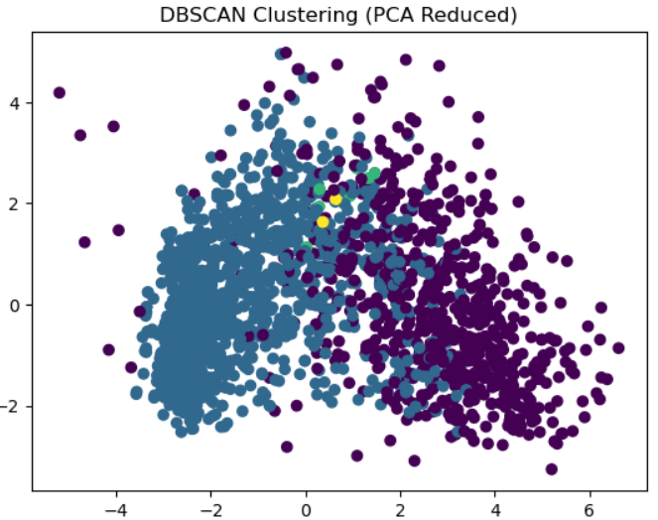
From the model results and by interpreting the above graph, we can see that a single dominant cluster (C0) was formed, with only a few smaller clusters identified alongside it (C1 and C2). In addition, a large portion of the data was classified as noise (-1). This indicates that DBSCAN struggled to identify meaningful density-based structures in the dataset.

4.5 Self-Organizing Map (SOM)

4.5.1 Model Overview
SOM is an unsupervised neural network that maps high-dimensional data onto a 2D grid while preserving topological relationships between data points. We chose this model as another alternative to K-Means, because it can identify natural groupings without predefined labels.
The 2D grid mentioned consists of neurons, with each neuron representing a cluster. Similar data points are mapped to nearby neurons. The training process involves initializing neuron weights, selecting a random data point, and identifying the BMU (Best Matching Unit). The BMU and its neighbours are then updated. This process is repeated over multiple iterations.

4.5.2 Model Configuration
Our SOM model was configured with the following values:
Grid size: | 15 * 15
Sigma: | 1.5
Learning rate: | 0.5
Iterations: | 2000

The SOM grid defines the number of neurons that will be used to represent the data in two dimensions and can be calculated using a heuristic formula ( $5*\sqrt{n}$ ), where n is equal to the number of data points. Our data set consists of 2240 data points, meaning the calculated value is 236 nodes. The closest square grid size is thus 15 * 15, which equals 225 nodes.
Sigma defines the radius of the neighbourhood function, which determines how many neighbouring neurons are updated during training. We selected a value of 1.5 in order to allow for moderate neighbourhood influence, ensure smooth transitions between neurons, and prevent overly fragmented clusters.
Learning Rate controls how quickly neuron weights are updated during the model training. Higher learning rates lead to faster convergence, but risks instability, while lower leaning rates are more stable at the cost of being slower. We chose a value of 0.5 for our model as a balanced starting point.
The iterations value refers to the number of times the SOM is trained using randomly selected data points. We chose a value of 2000 for this variable in order to provide adequate coverage of the dataset.

4.5.3 Results and Visualization
Customers were distributed across the SOM grid, dense regions indicated natural groupings, while sparse regions represented less common customer types. The distance map highlights boundaries between clusters.
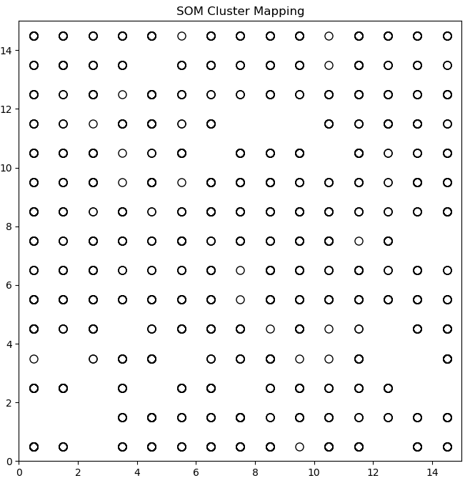
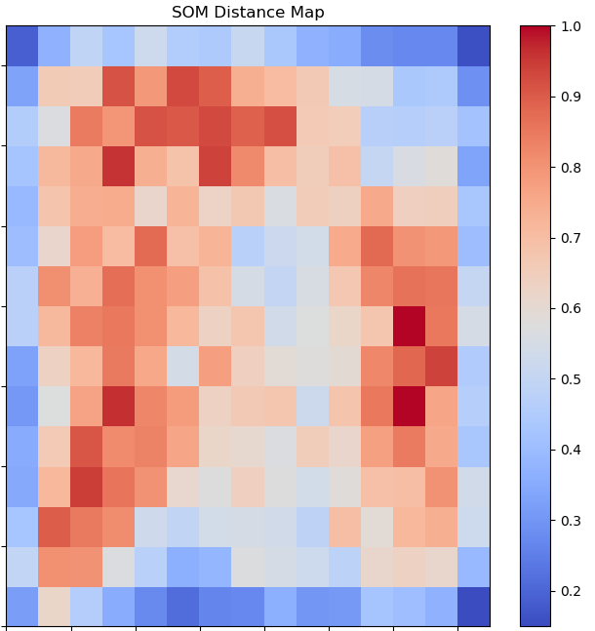

4.5.4 Interpretation
SOM revealed underlying structure and relationships in the data, but it was unable to produce clearly defined clusters without additional processing.

5. Evaluation

5.1 Evaluation Approach
The performance of the implemented clustering models (K-Means, DBSCAN, and SOM) were evaluated using a combination of Silhouette Score, cluster interpretability, visualization techniques, and business relevance/usability.

5.2 K-Means Evaluation
The K-Means model produced four distinct clusters from our dataset, with the following characteristics:
Silhouette Score | 0.1521
Cluster distribution | Reasonably Balanced
Notes:
- Strong relationships between features such as income and spending

- Clear separation observed in PCA visualizations

- Clusters were highly interpretable
(High-Value Buyers,
Budget Conscious Customers,
Digital Shoppers,
Passive Customers.)
These segments aligned well with real-world business use cases, making them useful to Woolworths Food for marketing strategies.

5.3 DBSCAN Evaluation
The DBSCAN model produced the following results:
Silhouette Score | 0.0787
Cluster distribution | One dominant cluster with very few smaller clusters
Notes:
- Large number of noise points (745 customers)

- Struggled to identify meaningful density-based structures within the dataset.

- The clusters were not well-balanced

- The results were difficult to interpret
- Many customers were excluded from segmentation due to being labeled as noise
As a result, DBSCAN was deemed less suitable for this dataset, than K-Means.

5.4 SOM Evaluation
The SOM model provided a different perspective by mapping customers onto a two-dimensional grid. After implementation, the model successfully preserved topological relationships. We were able to identify potential clusters by region density. The distance map highlighted boundaries between groups.
However, clusters were not explicitly defined, and additional processing would be required to extract clear segments. Interpretation was much more complex compared to K-Means. While SOM could provide valuable insights into the structure of the data, it was less practical for direct business application.

5.5 Model Comparison
Model | Silhouette Score | Strengths | Weaknesses
K-Means | 0.1521 | Clear clusters, easy to interpret, balanced segments | Requires predefined k
DBSCAN | 0.0787 | Detects noise, no need for k | High noise, poor cluster structure
SOM | N/A | Strong visualization, preserves data structure | No explicit clusters, complex interpretation

5.6 Final Model Selection
Based on our evaluations, K-Means produced the most interpretable and actionable clusters. DBSCAN proved to be ineffective due to excessive noise and weak separation, while SOM provided useful exploratory insights but lacked clear segmentation. Although K-Means did not achieve the highest possible Silhouette Score overall, it provided the best balance between cluster quality and interpretability, while still being applicable to the business. This led to K-Means being selected as the primary model for deployment in the web application, although the other models can still be selected and used should the user wish.

6. Deployment
Following the evaluation phase, we integrated all three models into a web-based interactive dashboard to enable real-time customer segmentation. The application was developed using Plotly DASH, which is a Python framework for building interactive web applications. Our web-application was then deployed on Render, a cloud platform that supports the hosting of web services. Our application enables users to input customer data for segmentation results and view the visual clustering results.
Our deployed solution follows a three-layer architecture. The frontend was built using Dash components (html, dcc) and provides the user with input forms for customer data as well as interactive graphs (scatter, pie, and bar charts). It also contains a model comparison dashboard and KPI cards with segment descriptions.
The backend of our application handles the Data Preprocessing (replication of the training pipeline), cluster prediction logic, and distance-based assignment to clusters. It makes use of NumPy for transformations and Pandas for data handling purposes.
The model layer stores the pre-computed cluster centroids, as well as the cluster-to-segment mappings, which support our primary model (K-Means), as well as secondary models (DBSCAN and SOM), which were implemented for the purposes of comparison and visualization.

6.1 Deployment Steps for Render
- Go to https://dashboard.render.com and login using your GitHub.
- Select the “New Web Service” option.
- Select the proper GitHub repository (MLG382-CYO-Project).
- Make sure you have a requirements.txt file that lists all the libraries required for the project to work.
- Fill in the service creation form (Name, Region, Repo Branch, Programming Language, Build Command, Start Command).
For the build command input, we used '$ pip install -r requirements.txt' so that Render installs the libraries instantly, eliminating wait time.
For the Start command input, we used ' gunicorn app.app:server --timeout 120'. The “app.app:server” refers to the fact that the 'app.py' is found within the 'app' folder and the server instance needs to be declared inside the app.py. We set the timeout to 120 is added to prevent the application from crashing due to trying to load everything at once.
- Choose an instance type to run the service on. For our project, we made use of the Free instance type.
- Click on “Create Web Service” to deploy. (The deployment progress can be viewed from the Events page in the Render Dashboard.)

6.2 Links
This project is open-source, and the work we have done can be reviewed on our GitHub repository, which can be found here: [GitHub Link]
We created an interactive dashboard application using Plotly DASH, this web application was deployed on Render and can be accessed at the following link: [Web Application Link]

7. Possible Future Improvements
There are many possible ways to improve the web application in the future. One such way could be the implementation of an automated model retraining pipeline. Our current model versions remain static after deployment. This means it is unable to adapt to changes in customer behaviour over time, making it unrealistic for a real-world retail environment where variables change frequently. Some form of retraining mechanism would have to be implemented that triggers when there is new data available for the models to train on. This can be in the form of integrated data pipelines that periodically collect new transactional data, preprocessing it, and retraining the clustering models before updating the deployed application. This would ensure that the clustering models remain relevant and continue to produce accurate segments.
From a user experience perspective, the interface of the of our application can be improved upon. The current DASH interface is functional and informative, but improvements can be made in terms of visual appeal. Enhancements could also include input forms that offer tooltips, and live data validation implemented.

